CYCLE 7
PROGRAM 35
//SANIN MOHAMMED N
//B21CSB55
//LINKED LIST OPERATION

PROGRAM CODE
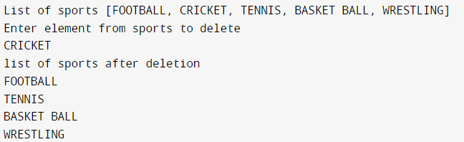
import java.util.*;

class list {
public static void main(String args[]) {
Scanner s = new Scanner(System.in);
List<String> l = new LinkedList<String>();
l.add("FOOTBALL");
l.add("CRICKET");
l.add("TENNIS");
l.add("BASKET BALL");
l.add("WRESTLING");
System.out.println("List of sports " + l);
System.out.println("Enter element from sports to delete");
String a = s.next();
if (l.contains(a)) {
l.remove(a);
} else {
System.out.println("element does not exist");
}
System.out.println("list of sports after deletion");
Iterator it = l.iterator();
while (it.hasNext()) {
System.out.println(it.next());
}
}
}

OUTPUT

PROGRAM 36
//SANIN MOHAMMED N
//B21CSB55
//QUICK SORT OPERATION

PROGRAM CODE
import java.util.*;

class Quicksort {
static void display(String a[]) {
for (String name : a) {
System.out.print(name + " ");
}
System.out.println();
}

public static int partition(String a[], int lb, int ub) {
String pivot = a[ub];
int i = lb - 1;
for (int j = lb; j < ub; j++) {
if (a[j].compareToIgnoreCase(pivot) < 0) {
i++;
String temp = a[i];
a[i] = a[j];
a[j] = temp;
}
}
i++;
String x = a[i];
a[i] = pivot;
a[ub] = x;
return i;
}

public static void sort(String a[], int lb, int ub) {
if (lb < ub) {
int pindex = partition(a, lb, ub);
sort(a, lb, pindex - 1);
sort(a, pindex + 1, ub);
}
}

public static void main(String args[]) {
Scanner s = new Scanner(System.in);
System.out.println("Enter size of list");
int n = s.nextInt();
String[] a = new String[n];
for (int i = 0; i < n; i++) {
System.out.println("Enter name");
a[i] = s.next();
}
System.out.println("The list before sort:");
display(a);
sort(a, 0, n - 1);
System.out.println("After sort:");
display(a);
}
}

OUTPUT
